Short term goals:

* Grids: 1 mm
* IPR:
  + IPR values all outside of the gum area

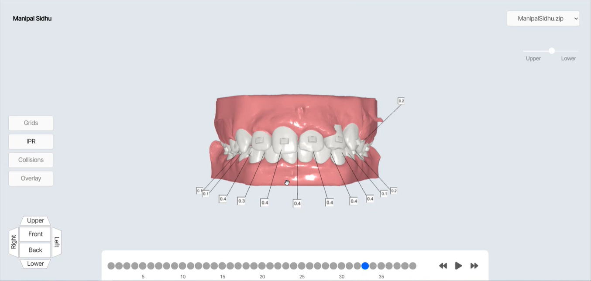

* Collisions:
  + Red mark at collisions:

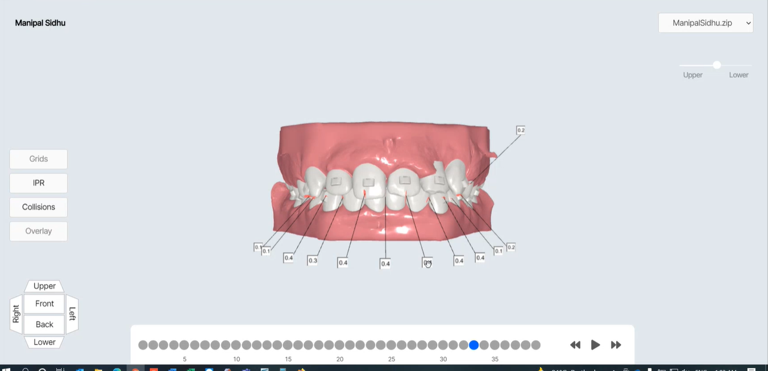

* Overlay:
  + Changes the color to show at each stage how much each tooth is moved

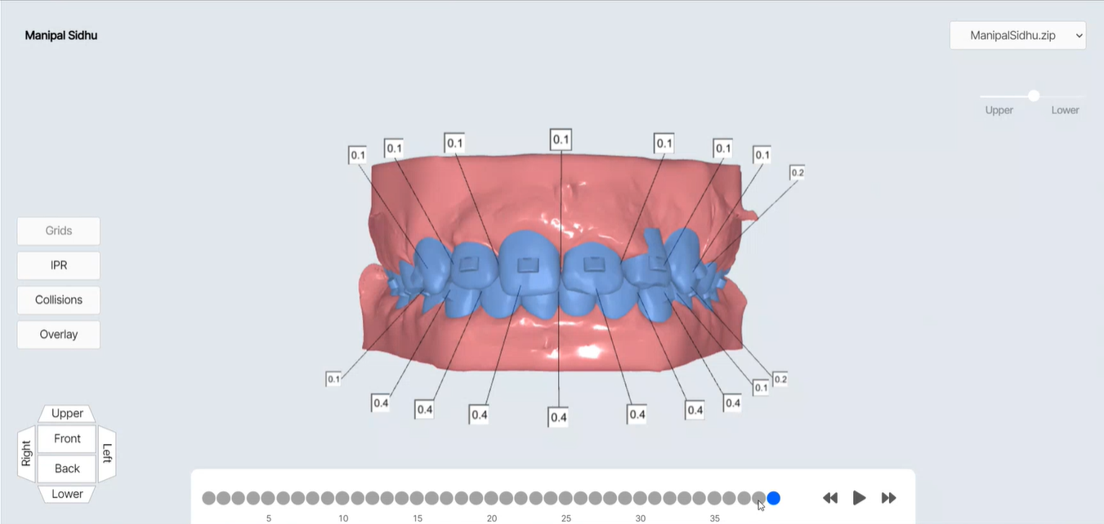

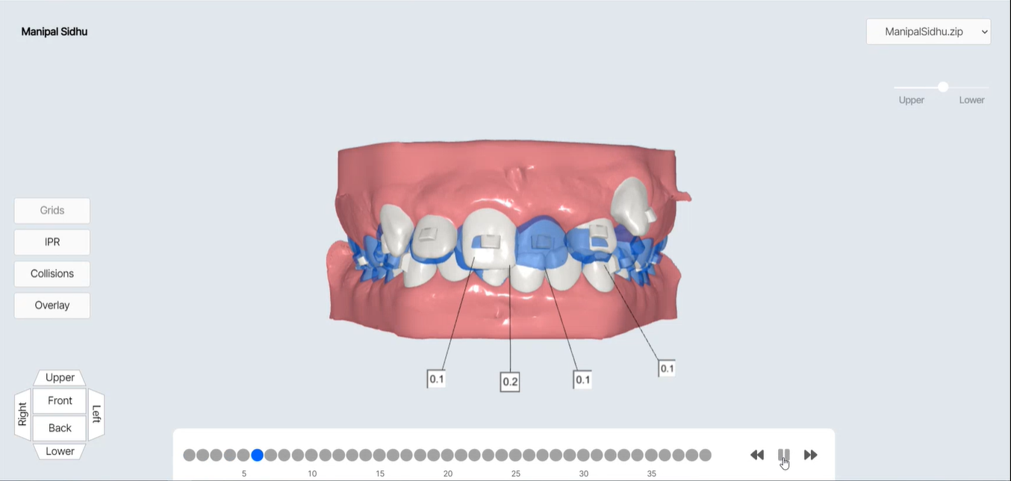

* Viewer-Play and move(Currently not possible because we are using images)
* Smooth motion, smooth zoom in-out

Long term goals:

* For Installer- Allow user to sign in -> Downloads patient files
* Allow user to drag/rotate the tooth-it will show collision automatically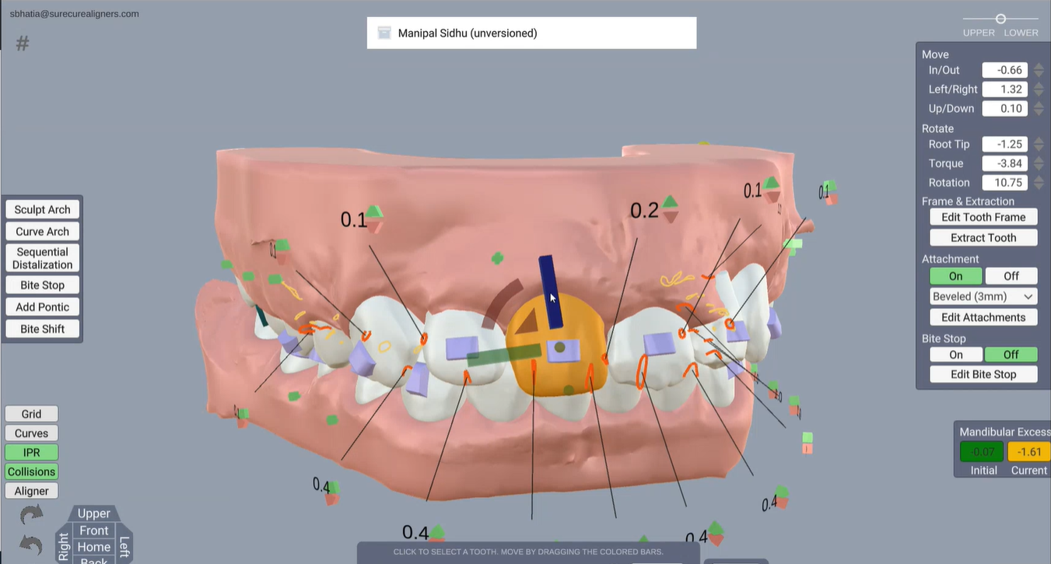
* Allow user to move/ rotate in upper/ lower view angle with different brush options as shown in image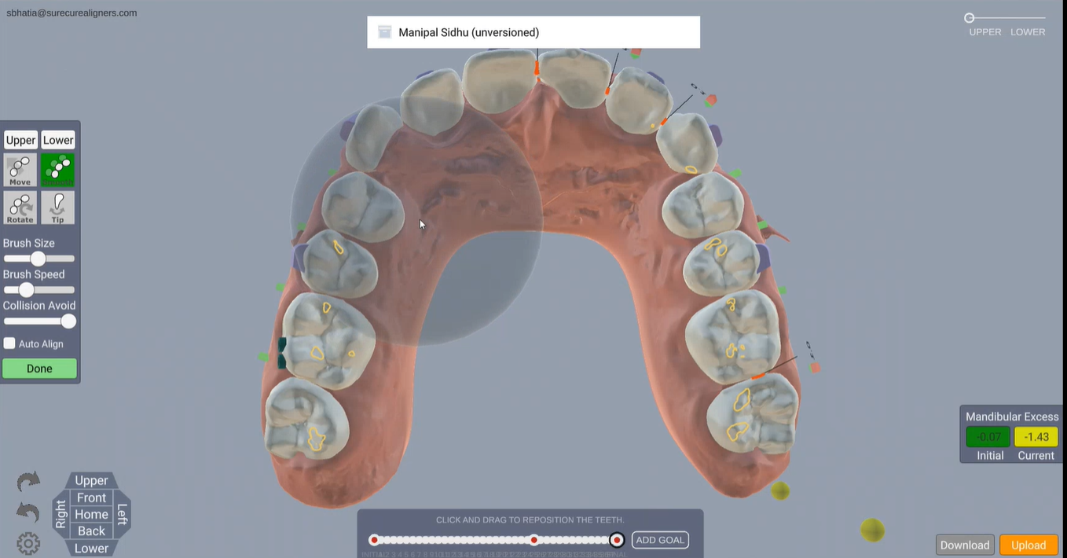
* Allow user to edit/move attachment

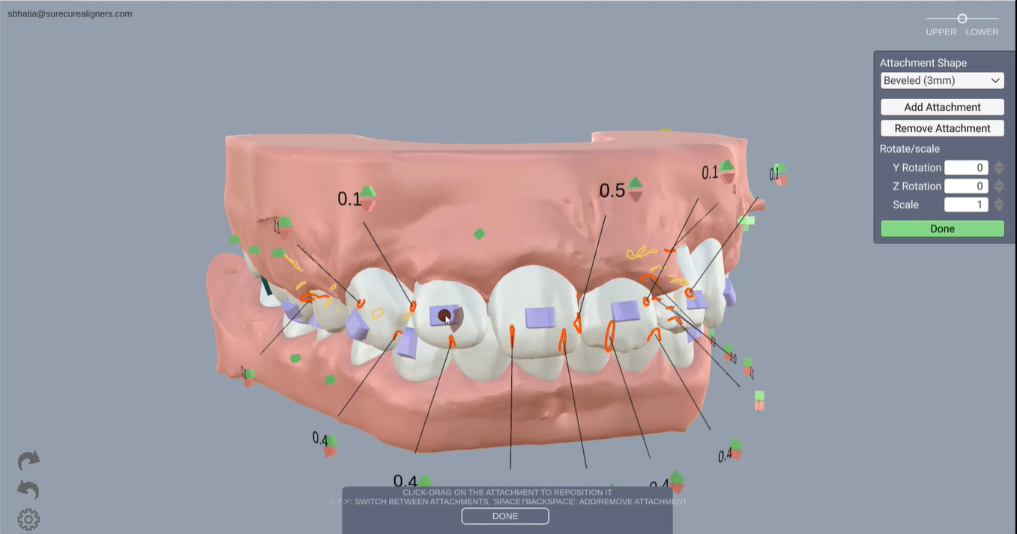

* Allow user to only upload initial stl file and generate the different stages by tooth movement/ rotation/ dragging, allow doctor to login and do corrections if any
* Make it Smoother